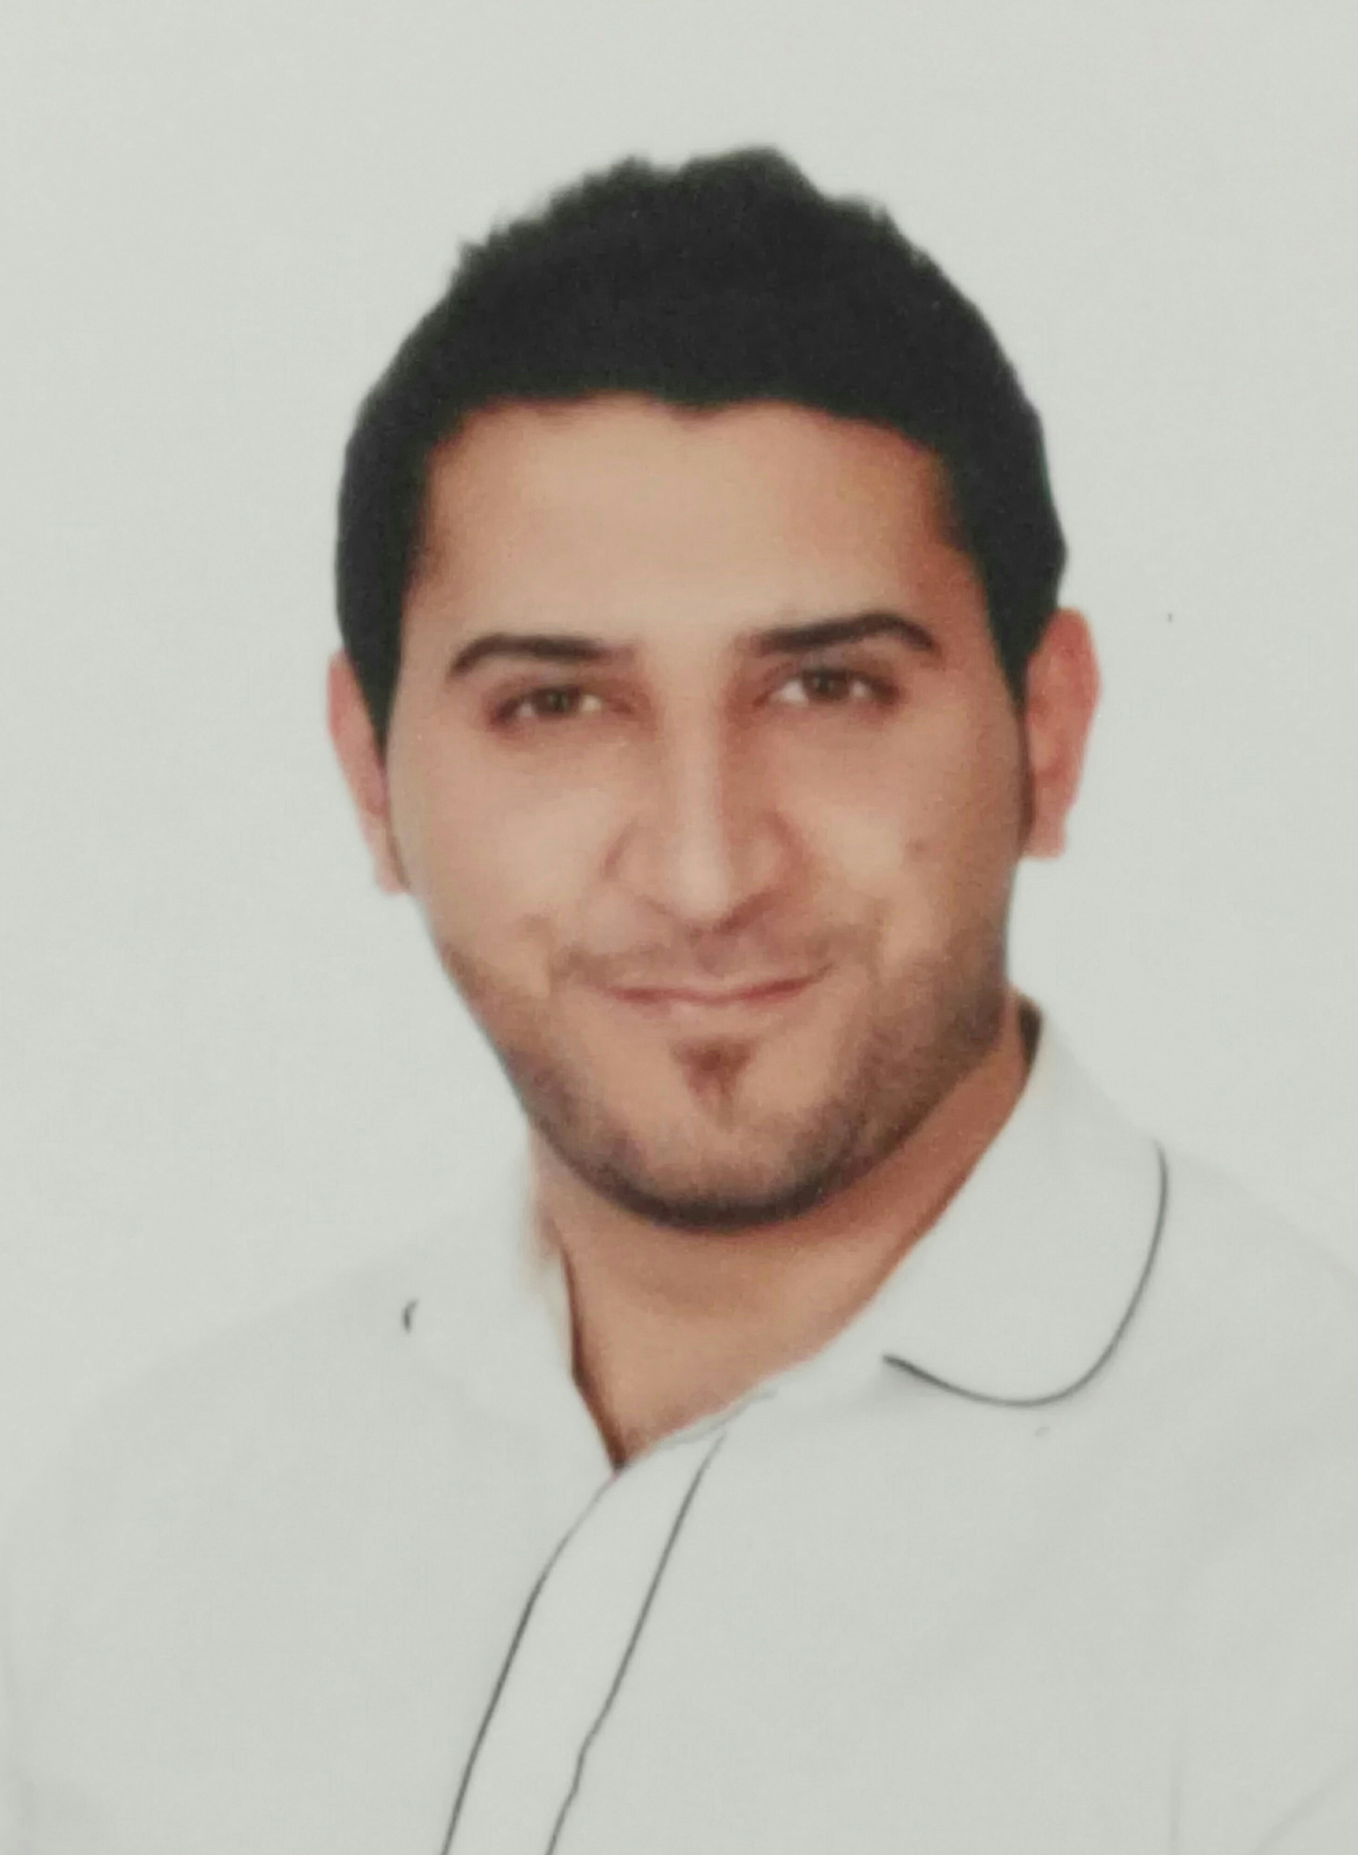
Curriculum Vitae
Personal Information:

- Name: Osama Salah Qutaishat
- Nationality: Jordanian
- Date of birth: 1990
- Address: Amman/Jordan
- Marital status: single
- Contact number : 00962799829820
- E-mail: osama.qtaishat.2014@hotmail.com.

Objective:
- A career opportunity that enables me to employ my skills, knowledge and abilities in a challenging environment .

Scientific qualifications:

Israa University Bachelor of Business Administration 2012

General skills:
I have a good knowledge in human resources.
Organizing information, team working, problem solving, leading, hardworking, Social, creative and flexible.

Areas of expertise: (multi-tasking skills):
ICDL course from Geneva Academy
Insurance certificate from AlArabi Insurance Company

It. skills:
Excellent knowledge in Microsoft office.
Experience:

Receptionist in Istishari hospital (12/2013 – 4/2016) Receiving and helping customers.

Teller in e-fawateercom Company (19/6/2018-until now)

Languages:
Arabic (mother tongue) English (good / spoken & written)

